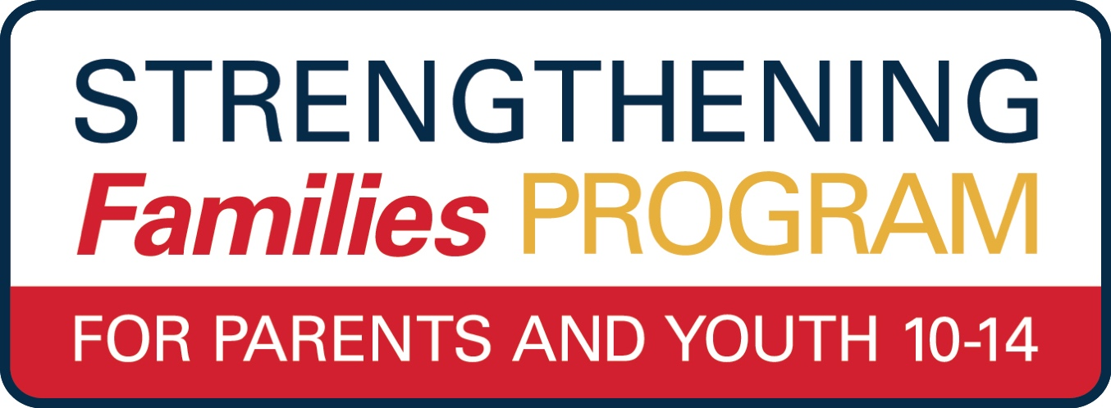

**Statewide *VIRTUAL***

Join Us Online This Winter Starting January 19, 2021

**Limited to the first 15 families- *register today!***

[**https://prosper.psu.edu/event/the-strengthening-families-program-for-parents-and-youth-10-14/**](https://prosper.psu.edu/event/the-strengthening-families-program-for-parents-and-youth-10-14/)

Join us online to help your youth navigate the

pressures and expectations of life during their teen years **to succeed and achieve a brighter future.**

*FREE of Charge*

**Winter Session Starts**

**January 19, 2021**

**SFP 10-14 promotes:**

· **Communication**

· **Family Bonding**

· **Problem Solving**

· **Positive Social Skills**

**Requirements:**

* **Families with youth ages 10-14**
* **Internet connection**
* **Phone or laptop with video capabilities**
* **Zoom capabilities**

**Contact by January 12, 2021:**

**Michele George, Penn State Extension**

**mzg226@psu.edu**

**by January 2, 2021.**